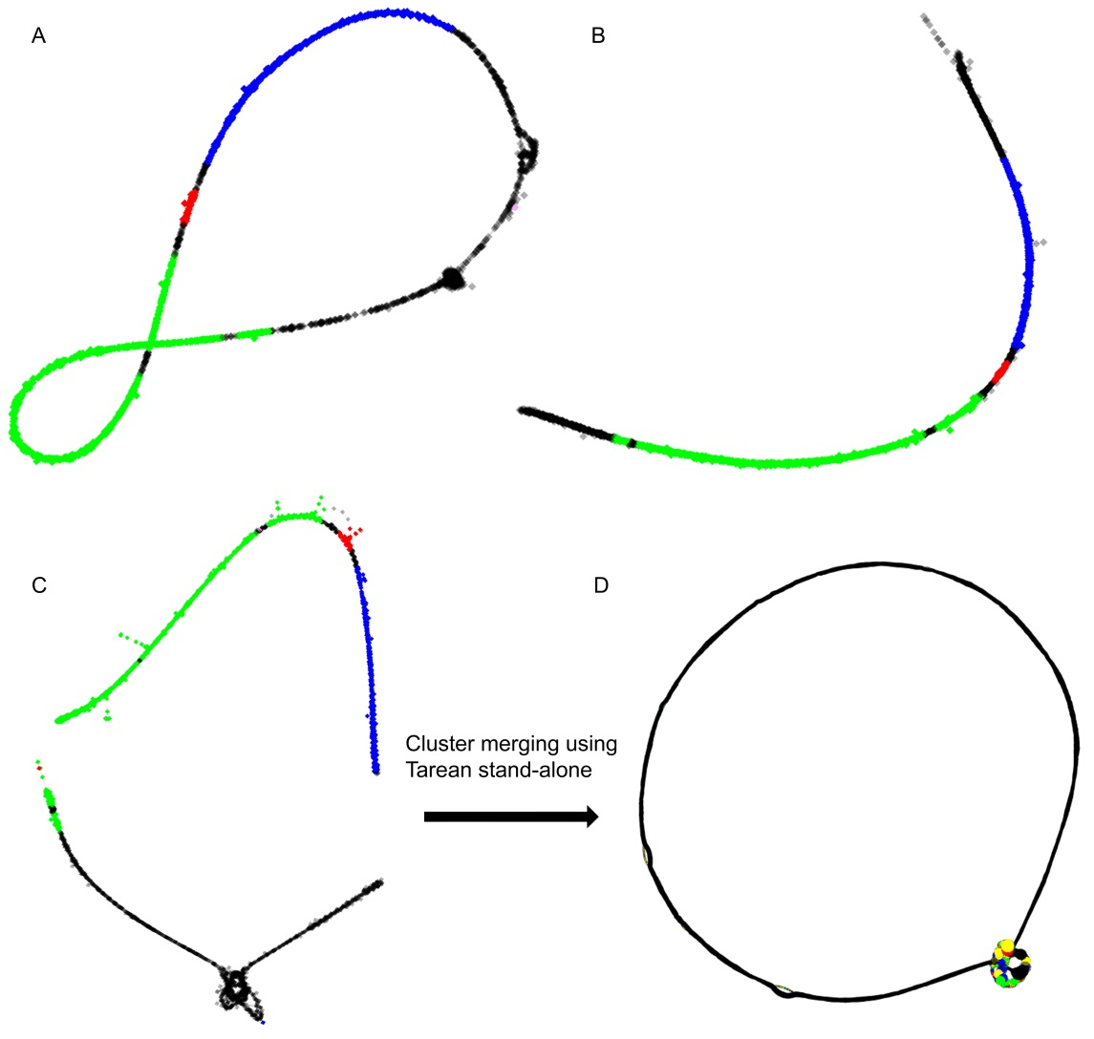
Figure S4 – 45S rDNA clusters. 25S rDNA is in green, 5.8S rDNA in red; and 18S rDNA in blue. Intergenic and internal transcribed spacers are in black. A – A. sativum CL57; B – A. ursinum CL91 has not provided circular shape and any connection to other clusters through mates was not observed; C – A. cepa CL82 and CL87 can be merged into a circular supercluster or graph using Tarean stand-alone (D).

