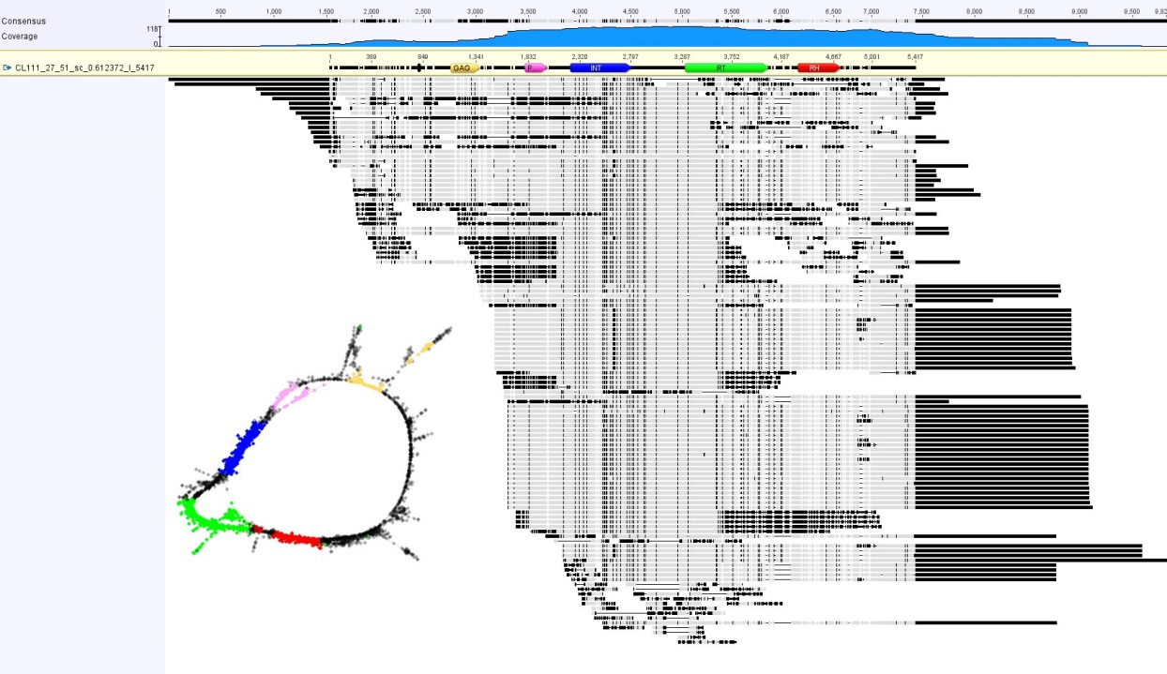
Figure S3. This is an alignment of contigs from cluster CL111 (Ty1/copia/TAR). The graph of the cluster is in the bottom left part. Aligned regions are depicted in grey. Unaligned sequences or mismatches are in black. Regions possesing coding domains are depicted in colours (GAG – yellow; PROT – pink; INT – blue; RT – green; and RH – red).

