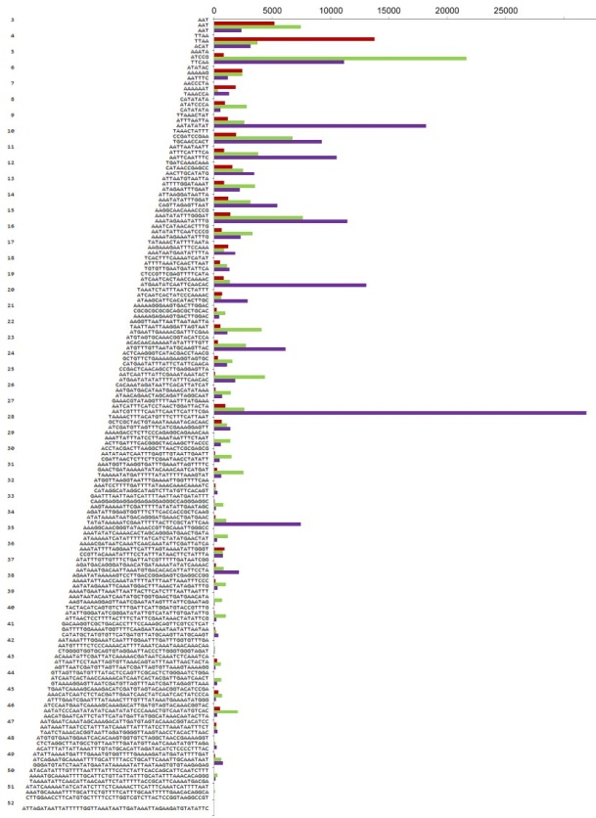
Figure S1. The most frequent short tandem motifs for each length between 3 and 52nt. This chart shows the most frequent tandem motifs in each length category for all three species. Bars represent number of reads with the motif in each species: A. cepa – brown, A. ursinum – green, and A. sativum – purple. The bars represent numbers of detected reads with a corresponding repeat. It is obvious that the most frequent tandems are (TTAA)_{n} in A. cepa, (ATCCG)_{n} in A. ursinum, and (AATCGTTTTCAATTCAATTCATTTCGA)_{n} in A. sativum. Motifs and abundancy of the other short tandem repeats can be found in supplementary tables (Table S1-4).

