Minutes of the 2nd Methodological Seminar IBP
MACHINES & METHODS
24. 6. 2022
Hall of the Institute of Biophysics of the Czech Academy of Sciences
Program of lectures:

1) Mgr. Jana Krejčí, Ph.D.: Chisostat – a device with a source of gamma radiation
2) Mgr. Karel Souček, Ph.D.: Small Animal Facility
3) Mgr. Radek Fedr: Methods of highthroughput microscopy

- The seminar was attended personally by 31 employees of the IBP.
- Mgr. Vratislav Peška, Ph.D. opened this 2nd methodological seminar of the Institute of Biophysics and took over the position of moderator.
- Mgr. Jana Krejčí, Ph.D. was the first to give a lecture entitled Chisostat – a device with a source of gamma radiation. She acquainted the students with the location and security of the chisostat and the working conditions during its use. She explained the basic concepts when working with the emitter and the possibilities of its use. She offered the opportunity to agree on possible cooperation in irradiation of samples. Finally, she answered questions asked by the audience.
- Subsequently, Mgr. Karel Souček, Ph.D. lectured with a lecture on Small Animal Facility. Dr. Souček introduced the audience to the operation of the menagerie for laboratory mice, the type of rooms and the type of mice. He introduced the team and its organization of the daily schedule. He mentioned the methods of fluorescence, luminescence X-ray. Showed cytokinetic results. In case of interest in cooperation, he referred to the contact Mgr. Víchová. Again, questions were raised after the lecture, to which Dr. Souček answered.
- The last lecturer was Mgr. Radek Fedr, who lectured on methods of highthroughput microscopy. Fedr spoke about the use and application of highthroughput microscopy methods. He shared the results of the given methods. And it offered the possibility of cooperation. Even after this lecture, questions were answered.
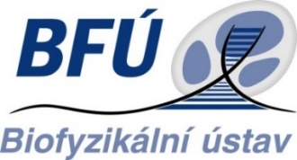
Minutes: J. Poláková

