Registration of the Methodological Seminar IBP
MACHINES & METHODS
Microscopy
25.3.2022
Hall of the Institute of Biophysics of the Czech Academy of Sciences

Program of lectures:

1) doc. Mgr. Václav Brázda, Ph.D.: Atomic Force Microscopy
2) Mgr. Hana Polášek-Sedláčková, Ph.D.: Quantitative image-based cytometers
3) Mgr. Soňa Legartová, Ph.D.: Lifetime Fluorescence: TCSPC and FRET
4) Václav Bačovský, Ph.D.: 3D SIM, lightning deconvolution and AiryScan detection

- The seminar was attended personally by 53 employees of the BFÚ. An on-line transmission was also mediated. This opportunity was used by the organizer of this seminar, Mgr. Vratislav Peška, Ph.D., who could not attend in person for health reasons.
- Mrs. Director doc. RNDr. Eva Bártová, Ph.D., DSc. opened this 1st methodic seminar of the Institute and took over the position of moderator.
- Doc. Mgr. Václav Brázda, Ph.D. was the first to give a lecture entitled Atomic Force Microscopy. Among other things, he drew attention to his colleague Mgr. Lukáš Fojta, Ph.D., who is an expert in the field. After the lecture, questions were asked, both from the audience in the hall and online, to which Dr. Brázda immediately answered.
- The second lecturer was to be Mgr. Hana Polášek-Sedláčková, Ph.D. with her lecture Quantitative image-based cytometry. Dr. Sedláčková was unable to attend the seminar due to health reasons.
- Subsequently, Mgr. Soňa Legartová, Ph.D. lectured with the lecture Fluorescence Lifetime: TCSPC and FRET. Where she talked about the FRET-FLIM method on the Leica TCS SP 8 SMD microscope. Again, after the lecture, questions were raised to which dr. Legartová answered.
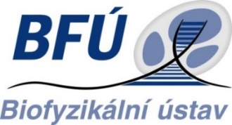
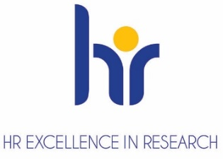
- Ing. Václav Bačovský, Ph.D., who lectured on 3D SIM, lightning deconvolution and AiryScan detection. Here he talked about the principles and technical parameters of these methods on microscopes from Leica and Zeiss. Even after this lecture, questions were answered.

Minutes: J. Poláková

