Meeting of the ISAB (meetings)

ISAB
Implementation of the HR Award
October 6, 2022, Lecture Hall of the Institute of Biophysics, CAS

- There was an on-line transmission via zoom, however, some participants showed their presentations personally. 47 IBP employees personally participated in the seminar. Another 33 scientists used the on-line option, both ISAB members and IBP employees.

- Jean Louis Mergni's presented a lecture on the results of SYMBIT project and further perspectives. His presentation was received positively and ISAB recommended continuation of his research activities at the Institute at least till the end of the year. The director of the Institute, Eva Bártova, agreed with this conclusion.

- Director of the Institute, Eva Bártová, described the events at the Institute since the last ISAB meeting. She also introduced the OP JAK project prepared by the Institute in collaboration with Institute of Scientific Instruments and St. Annes Hospital. ISAB supported the effort of the Institute in this direction.

- The new publication strategy of BFÚ suggested by the Institute Council was discussed, specifically publishing in MDPI journals. The Council did not recommend publishing in the MDPI publishing house in spite of the fact that some journals are highly cited and have sufficiently high IF. ISAB supported the approach of the Institute.

- The program followed by presentations of young scientists and students selected from each department giving a scientific lecture on the research topic. Subsequently, ISAB had evaluated the presentations and gave response on their quality to the management of the Institute.

- Before the very end, a discussion was opened on how to motivate young scientists to be interested in being group leaders and how ISAB could help them to do so.

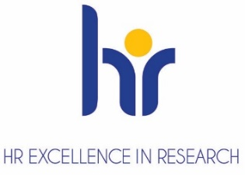
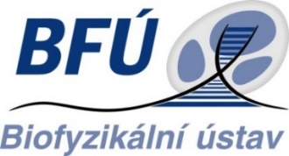
Zápis: J. Poláková

