Invitation to the 1/2023

Machines & Methods IBP meeting

Programme:

**MetaCentrum - grid service for scientific computations and collaborative research**



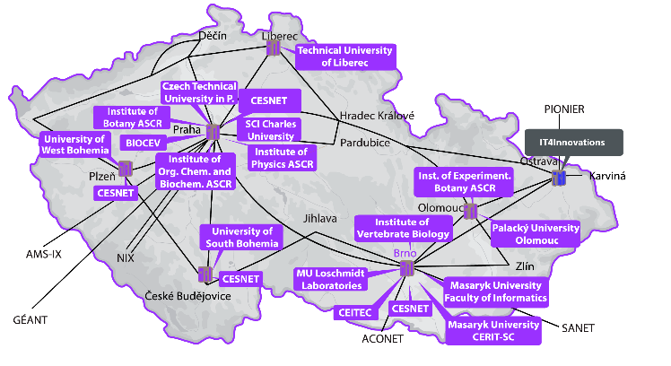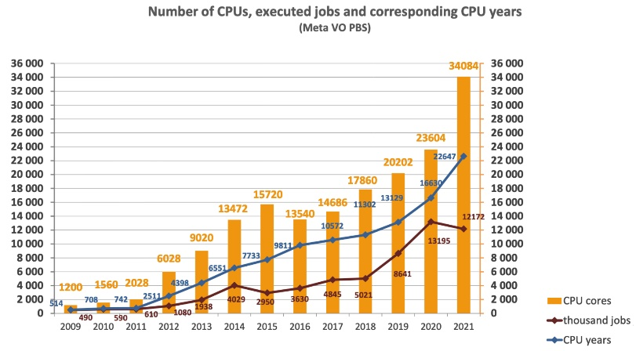

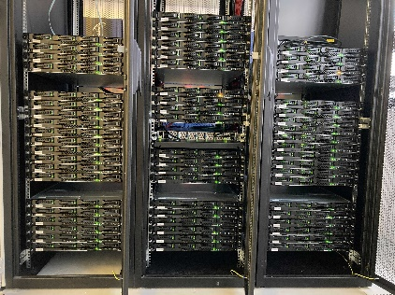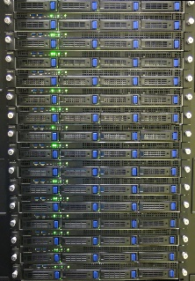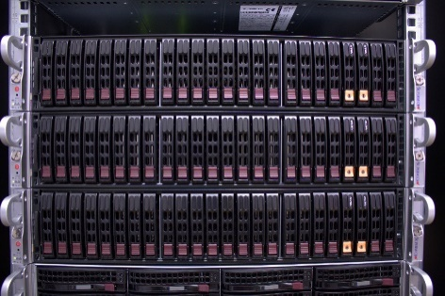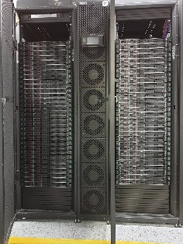

**Invited Speaker: Jiří Vorel**

**23rd March 2023 13:00**

**IBP - lecture hall**