IBP career day: Per Aspera Ad Astra

30. 9. 2022
Young researchers of the Institute of Biophysics (IBP) of the Czech Academy of Sciences are inviting students and postdocs to IBP career day: Per Aspera Ad Astra focused on future career possibilities in the academic and industrial spheres. During the event, four outstanding scientists will share stories of their scientific journeys and will lead popular round table discussions on various topics.
Date & Location: 11.11.2022, Lecture Hall at the Institute of Biophysics
Confirmed speakers:
Vladimíra Petráková is a group leader at Heyrovsky Institute of Physical Chemistry, CAS, where she studies sub-diffraction manipulation of light using plasmonic nanoparticles. After her studies at Czech Technical University in biomedical engineering, she moved to Free University Berlin, where she worked in the Institute of Experimental Physics and Institute of Chemistry and Biochemistry as a Humboldt Fellow. She co-founded Czexpats in Science and is a mother of four children.
Martin Víta is an assistant professor at the Department of mathematics, Prague University of Economics and Business, and a research assistant at the Institute of Physics, CAS. During his Ph.D. studies in Computer systems and technologies at Masaryk University, he undertook an internship at FEP/INESC Porto. He worked as an R&D analyst at the Technology Agency of the Czech Republic. In 2016, he founded ResearchJobs.cz – the first job portal focused on academic and research positions in the Czech Republic.
Panagiotis Alexiou is a research group leader and head of the Bioinformatics Core Facility at the Central European Institute of Technology of Masaryk University. Before joining CEITEC MU, Panagiotis worked as a Research Associate at the University of Pennsylvania in the United States. He has authored several scientific manuscripts and secured national and international funding including the prestigious EMBO Installation Grant.
Vratislav Košťál is a chief product officer (R&D) in TESCAN, a Brno-based, global producer of electron microscopes. Vratislav studied analytical chemistry at the Brno University of Technology, then he developed instruments at the Academy of Sciences of the Czech Republic. He worked for five years at the University of Minnesota, USA, where he first encountered an electron microscope. After returning to Brno, he joined TESCAN as an application engineer.
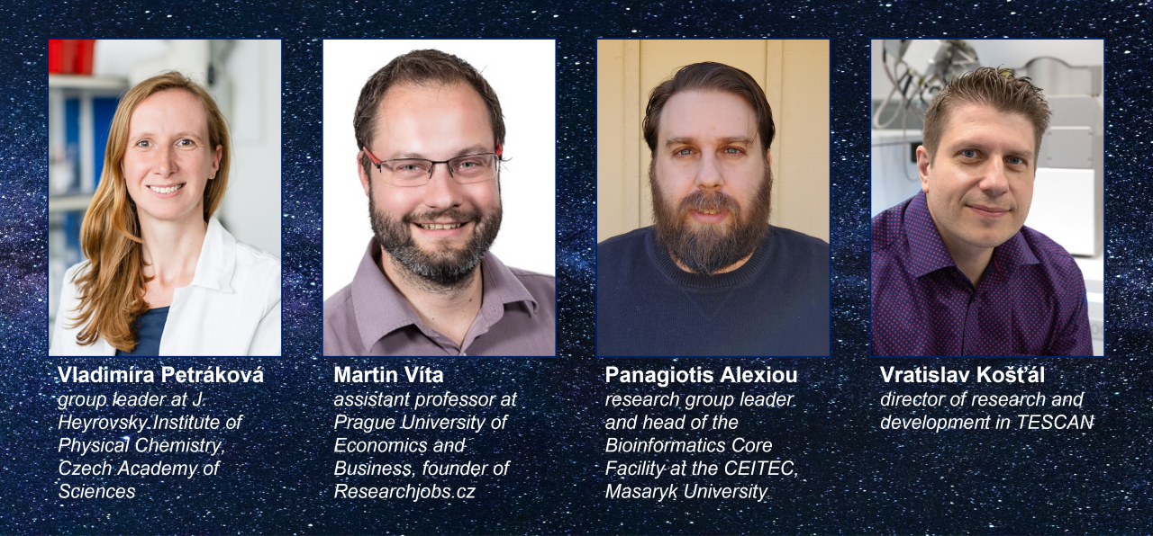
Program:
12:30-13:00 registration
13:00-13:10 introduction by Hana Polasek-Sedlackova on behalf of the organization team
13:10-13:40 Using Professional and Personal Networks for Career Decisions and Progress by Vladimíra Petráková
group leader at J. Heyrovsky Institute of Physical Chemistry, Czech Academy of Sciences
chair: Paolo Fagherazzi
13:40-14:10 Beyond Job Advertisements of Research and Academic Positions by Martin Víta
assistant professor at Prague University of Economics and Business, founder of Researchjobs.cz
chair: Václav Bačovský
14:10-14:30 coffee break
14:30-15:00 The Odyssey of Becoming an Independent Researcher by Panagiotis Alexiou
research group leader and head of the Bioinformatics Core Facility at the CEITEC, Masaryk University
chair: Pavlína Pokorná
15:00-15:30 Personal Story: My career path from academia to industry by Vratislav Košťál, chief product officer (R&D)
in TESCAN, Brno electron microscope manufacturer
chair: Vojtěch Novohradský
15:30-15:45 coffee break
15:45-16:45 round table discussions
from 16:45 networking with beer and pizza
Round table discussions topics:
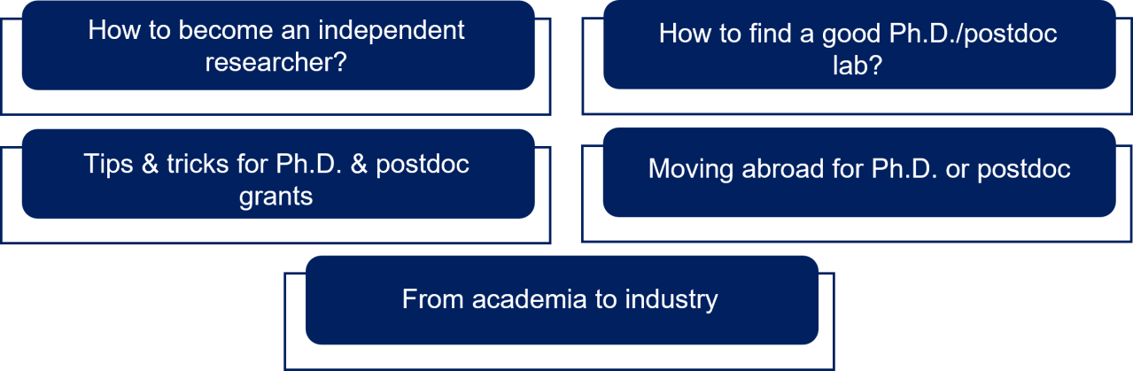
Bulletin board:
Throughout the event, the bulletin board with additional information about national and international career events, scientific skills courses, management courses, and open positions in the academy and industry will be installed at IBP.
Registration:
Registration is free of charge. By registering you are helping us to better estimate the number of people that will attend,
and the food & drinks needed. Thank you for registering!
Registration deadline: 2nd November 2022
Registration form can be found here.
