1. methodical seminar IBP
MACHINES & METHODS
Microscopy
25. 3. 2022
hall of the Institute of Biophysics of the Czech Academy of Sciences

1) doc. Mgr. Václav Brázda, Ph.D.: Atomic Force Microscopy
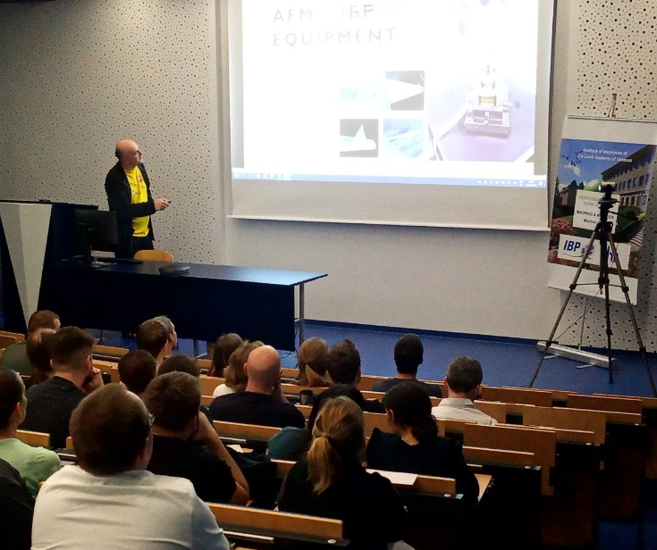

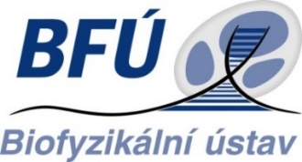
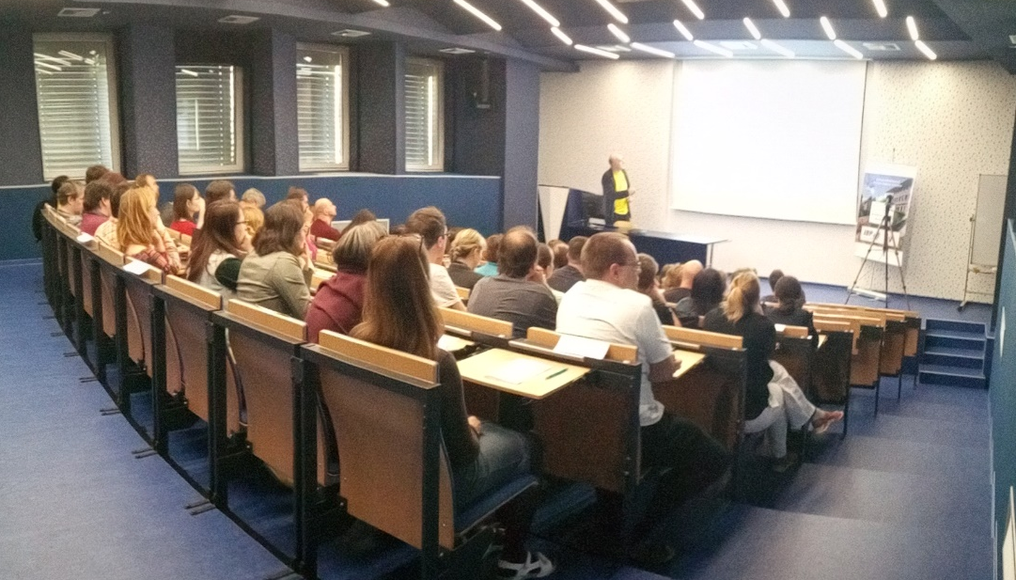
1. methodical seminar IBP
MACHINES & METHODS
Microscopy
25. 3. 2022
hall of the Institute of Biophysics of the Czech Academy of Sciences

2) Mgr. Soňa Legartová, Ph.D.: Fluorescence Lifetime: TCSPC and FRET

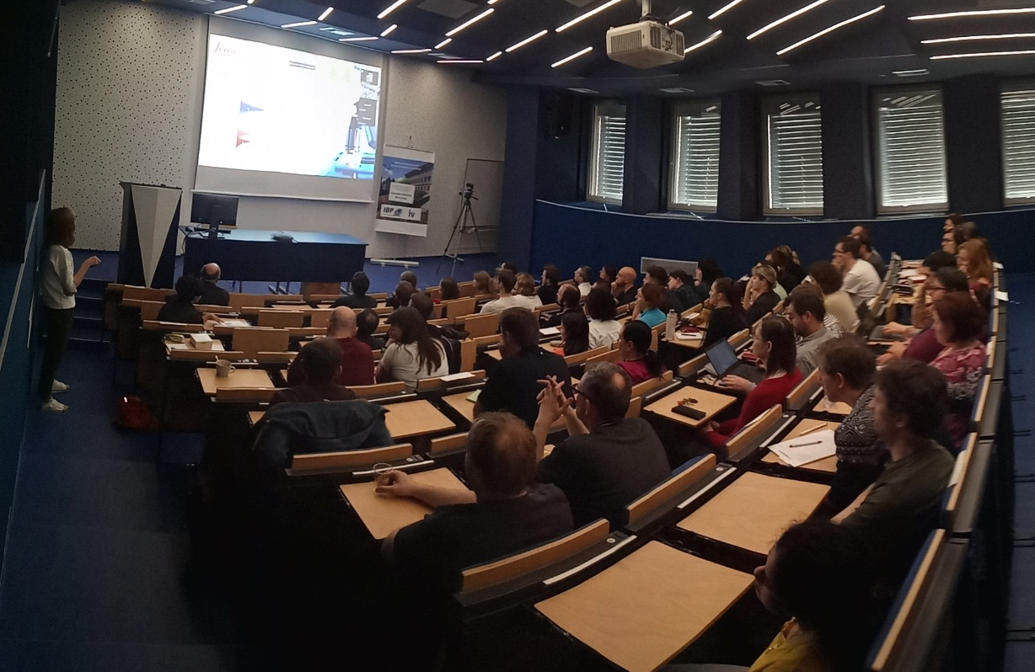
1. methodical seminar IBP
MACHINES & METHODS
Microscopy
25. 3. 2022
hall of the Institute of Biophysics of the Czech Academy of Sciences

3) Ing. Václav Bačovský, Ph.D.: 3D SIM, lightning deconvolution and AiryScan detection
