2. methodical seminar IBP
MACHINES & METHODS
24. 6. 2022
hall of the Institute of Biophysics of the Czech Academy of Sciences

1) Mgr. Jana Krejčí, Ph.D.: Chisostat – a device with a source of gamma radiation
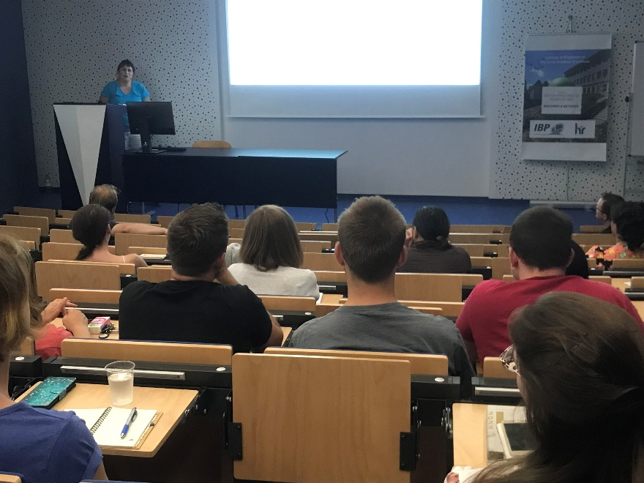

2. methodical seminar IBP

MACHINES & METHODS
24. 6. 2022
hall of the Institute of Biophysics of the Czech Academy of Sciences

2) Mgr. Karel Souček, Ph.D.: Small Animal Facility
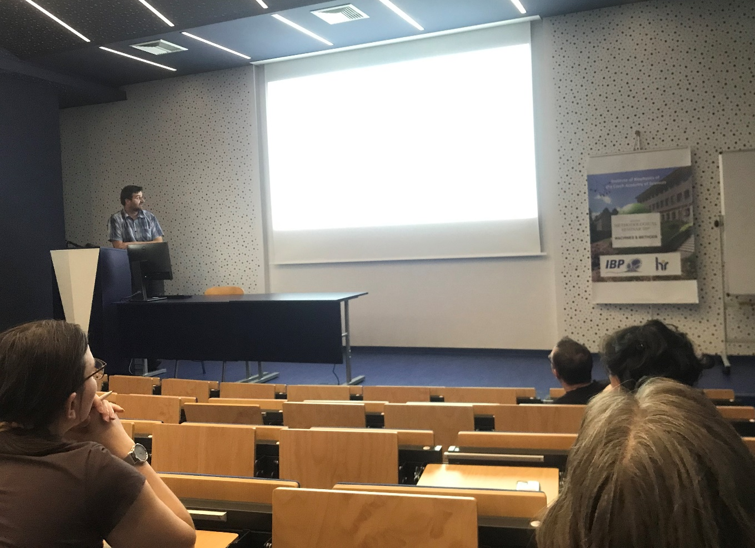
2. methodical seminar IBP
MACHINES & METHODS
24. 6. 2022
hall of the Institute of Biophysics of the Czech Academy of Sciences

3) Mgr. Radek Fedr: Methods of highthrouughput microscopy
